ASSIGNMENT: 2

- Draw and label diagrams of star, bus, and mesh network topologies on paper or using any drawing tool. For each, write one real-world app or service (like WhatsApp, Flipkart, or IPL streaming) that could use that topology and explain why in 1-2 lines.
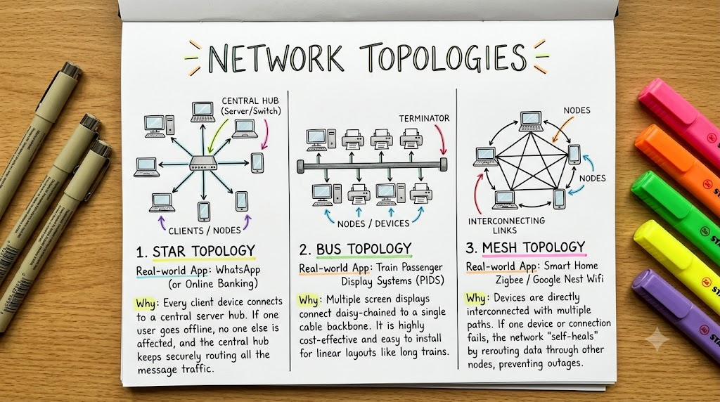
- Create a comparison table listing at least four pros and four cons for each of these topologies: star, bus, ring, mesh. Include a column for 'Best Use Case' and give an example from apps you use (e.g., Instagram, Zomato, Paytm).

Network Topology Comparison Table
Topology | Advantages (Pros) | Disadvantages (Cons) | Best Use Case | Real-World Example
Star | 1. Easy to detect faults.  2. Easy to add or remove devices.  3. Good performance with a switch.  4. Easy to manage. | 1. Central switch failure affects the entire network.  2. Requires more cables.  3. Performance depends on the central device.  4. Limited by available ports. | Home networks, offices, schools, and computer labs. | Home or office LAN: Computers and other devices connect to a central switch or Wi-Fi router.
Bus | 1. Requires less cable.  2. Low installation cost.  3. Simple to set up for small networks. | 1. Backbone cable failure can stop the entire network.  2. Performance decreases as traffic increases.  3. Faults are difficult to locate.  4. Data is shared across the common cable. | Small, temporary, or legacy networks. | Early Ethernet: 10Base2 and 10Base5 networks.
Ring | 1. Token passing prevents data collisions.  2. Provides fair access to devices.  3. Offers predictable performance under load. | 1. A cable or node failure may disrupt the ring.  2. Adding or removing devices can be difficult.  3. Troubleshooting can be complex.  4. Delay increases as data passes through more nodes. | Legacy networks and specialized systems requiring predictable communication. | IBM Token Ring: An older LAN technology.
Mesh | 1. Provides multiple communication paths.  2. Offers high reliability and redundancy.  3. Can reroute traffic when a link fails.  4. Supports fault tolerance. | 1. Expensive to install.  2. Requires many cables or connections in a full mesh.  3. Configuration and maintenance are complex.  4. Requires more ports and network resources. | Internet backbones, data centers, and networks requiring high availability. | Internet backbone: Core routers use multiple interconnected paths to maintain connectivity.

Examples of Topology in Modern Applications
Application or System | Topology Concept | Explanation
Home Wi-Fi | Star | Devices connect through a central router or access point.
Instagram | Hybrid | Servers, load balancers, and data centers use a combination of network designs.
Zomato | Hybrid | Distributed services and infrastructure support reliable communication and traffic handling.
Paytm | Hybrid | Redundant network paths and distributed infrastructure help maintain service availability.

- Imagine you are designing a new multiplayer mobile game like PUBG or Free Fire. Choose a suitable network topology for the game servers and justify your choice in 3-4 lines, mentioning how it would impact speed, reliability, and cost.
Chosen Network Topology: Mesh Topology
- Speed: Multiple network paths can help game data travel efficiently and reduce delays when the network is well designed.
- Reliability: If one network link fails, an alternate path can keep the game servers connected and reduce interruptions.
- Cost: Mesh networking can be expensive because it requires additional links, network equipment, and maintenance.
- Best Choice: A partial mesh topology is suitable for a multiplayer game like PUBG or Free Fire because it balances low latency, reliability, and cost without connecting every server directly to every other server.

- Given this scenario: A small Flipkart-style warehouse wants to connect 8 computers for order processing and inventory updates. Recommend a network topology, sketch a quick diagram, and explain your reasoning in 2-3 lines.<br><br><em><strong>Hint:</strong> Consider factors like cost, ease of troubleshooting, and future expansion.</em>

Recommended Topology: Star Topology
Diagram:
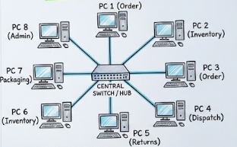
Reasoning (2–3 lines):
- Star topology is cost-effective and easy to manage because all 8 computers connect to one central switch.
- If one computer fails, the other computers continue working, and troubleshooting is simple.
- More computers, barcode scanners, or printers can be added easily by connecting them to available switch ports.

